Once upon a time 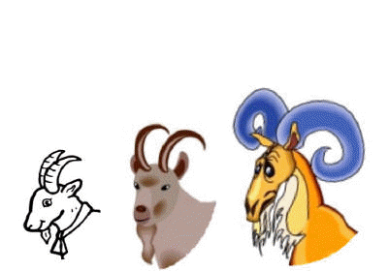
there were three Billy Goats called Gruff.
In the winter they lived in a barn in the valley.
When spring came they longed to travel
up to the mountains to eat the lush sweet grass.
On their way to the mountains
the three Billy Goats Gruff had to cross a rushing river.
But there was only one bridge across it,
made of wooden planks.
And underneath the bridge
there lived a terrible, ugly, one-eyed troll.
Nobody was allowed to cross the bridge
without the troll's permission
and nobody ever got permission.
He always ate them up.
The smallest Billy Goat Gruff was first to reach the bridge. Trippity-trop, trippity-trop
went his little hooves as he trotted
over the wooden planks.
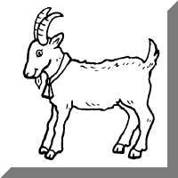
Ting-tang, ting-tang went the little bell round his neck.
“Who’s that trotting over my bridge?” growled the troll from under the bridge.
"Billy Goat Gruff," squeaked the smallest goat in his little voice.
"I'm only going up to the mountain to eat the sweet spring grass."
"Oh no, you're not!" said the troll.
"I'm going to eat you for breakfast!"
”Oh no, please Mr. Troll," pleaded the goat.
"I'm only the smallest Billy Goat Gruff.
I'm much too tiny for you to eat,
and I wouldn't taste very good.
Why don't you wait for my brother,
the second Billy Goat Gruff?
He's much bigger than me
and would be much tastier."
The troll did not want to waste his time on a little goat if there was a bigger and better one to eat.
"All right, you can cross my bridge," he grunted.
"Go and get fatter on the mountain
and I'll eat you on your way back!"
So the smallest Billy Goat Gruff
skipped across to the other side.
The troll did not have to wait long
for the second Billy Goat Gruff.
Clip-clop, clip-clop went his hooves
as he clattered over the wooden planks.
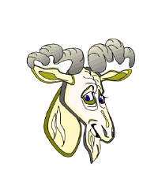
Ding-dong, ding-dong went the bell around his neck.
"Who's that clattering across my bridge?"
screamed the troll,
suddenly appearing from under the planks.
“Billy Goat Gruff, " said the second goat in his middle-sized voice.
"I'm going up to the mountain
to eat the lovely spring grass."
"Oh no you're not!" said the troll.
"I'm going to eat you for breakfast."
“Oh, no, please,” said the second goat.
"I may be bigger than the first Billy Goat Gruff,
but I'm much smaller than my brother,
the third Billy Goat Gruff.
Why don't you wait for him?
He would be much more of a meal than me. "
The troll was getting very hungry,
but he did not want to waste his appetite
on a middle-sized goat
if there was an even bigger one to come.
"All right, you can cross my bridge," he rumbled.
“Go and get fatter on the mountain
and I'll eat you on your way back!”
So the middle-sized Billy Goat Gruff scampered across to the other side.
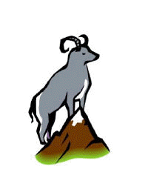
The troll did not have to wait long
for the third Billy Goat Gruff.
Tromp-tramp, tromp-tramp went his hooves
as he stomped across the wooden planks.
Bong-bang, bong-bang went the big bell round his neck.
“Who’s that stomping over my bridge?" roared the troll, resting his chin on his hands.
“Billy Goat Gruff, " said the third goat in a deep voice.
" I'm going up to the mountain
to eat the lush spring grass. "
" Oh no you're not, " said the troll
as he clambered up on to the bridge.
"I'm going to eat you for breakfast!"
"That's what you think,”
said the Biggest Billy Goat Gruff.
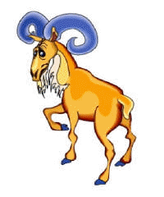
Then he lowered his horns, galloped along the bridge
and butted the ugly troll.
Up, up, up went the troll into the air...
then down, down, down into the rushing river below.
He disappeared below the swirling waters,
and was gone.
So much for his breakfast,
thought the biggest Billy Goat Gruff.
“Now what about mine !"
And he walked in triumph over the bridge
to join his two brothers on the mountain pastures.
From then on everyone could cross the bridge whenever they liked -
Thanks to the Three Billy Goats Gruff.

